Date: / /

Manager Human Resources­

Dear Sir/Madam­­­

My name is Ikeba Hamilton and I wish to apply for any vacancy available within your organization.

I am earnest, a team player, goal-oriented and I also perform well in a fast-paced environment. I am a person of value, respect, standard and I always take my job seriously.

In everything that I do, I always do it to the best of my ability, so I can hereby assure you, that I will be a great asset to your company .Thank you for your consideration.

Yours sincerely,

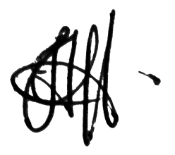Ikeba Hamilton

____________________

Curriculum Vitae

**PERSONAL INFORMATION**

FULL NAME: IKEBA ALEXIA MAIY HAMILTON

DATE OF BIRTH: AUGUST 15th 1994

GENDER: FEMALE

NATIONALITY: TRINIDADIAN

ADDRESS: LP #51 AUGUSTINE TERRACE, DIEGO MARTIN

CONTACT : 1 868 358 -1255, 1 868 790-4186

**EDUCATION**

**PRIMARY SCHOOL:** MORVANT ­NORTH GOV’T PRIMARY SCHOOL (2000-2001)

MALICK GIRLS’ RC PRIMARY SCHOOL (2001-2006)

EL SOCORRO NORTH GOV’T PRIMARY SCHOOL (2006-2007)

**SECONDARY SCHOOL:** ST FRANCOIS GIRL’S COLLEGE BELMONT (2007-2012)

**QUALIFICATION:** PRINCIPLES OF BUSINESS (3)

INTEGRATED SCIENCE (3)

ENGLISH A (3)

SOCIAL STUDIES (3)

MATH. (3)

**OTHER OUALIFICATION/ ACHIEVEMENT:**   
CERTIFICATION : (DISTINCTION) IN ‘GRADED EXAMINATION IN SOLO STEELPAN PERFORMANCE AT THE UNIVERSITY OF THE WEST INDIES.

**­HOBBIES/ OTHER INTEREST**

MUSIC  
SINGING  
INTERIOR DESIGNING  
DESIGNING APPAREL

**REFERENCES**

MS. ABI DEMI POLLIDORE / TEACHER - 1 868 372 -3811

MR. KIJONE FRANKTOM / POLICE OFFICER - 1 868 357-4531

MR. ADRIAN BEAUCHE / CEO REALLY NICE MEDIA - 1 868 688-2777

MS. NICOLE WATSON / TEACHER– 1 868 762 7070

MS. VERONICA WILLIAMS / VERTERNARIAN – 1 868 682 3457

MR. IAN HOLLAND/ OWNER & FOUNDER OF LINEAS DE PLATA – 1 868 6826818

**EMPLOYMENT HISTORY**

**EMPLOYER** **POSITION**

ST PETER’S RC SCHOOL LIBRARY ASSISTANT

RADICAL DESIGNS SALES CLERK

REALLY NICE MEDIA ASSISTANT (INTERN)

CARIBBEAN TREATS MERCHANDISER / PACKAGING

CHAMS BOUTIQUE SALES CLERK

RHAND CREDIT UNION HR MANAGER ASSISTANT (INTERN)

GIANT SUPERMARKET MERCHANDISER

To whom it may concern

Dear sir / madam,

It is with great pleasure that I recommend Ikeba Alexia Maiy Hamilton. I have known her for many years and I must say that Ms. Hamilton has always portrayed a high degree of intelligence, enthusiasm and determination towards her work. She is focused and has a driven spirit for greatness, so I can definitely say; she is a leader rather than a follower.

In addition, she has proven her ability of willingness to follow instructions and respect in the workplace

Ms. Hamilton will be a great asset to any organization, and I am delighted to give my wholehearted endorsement.

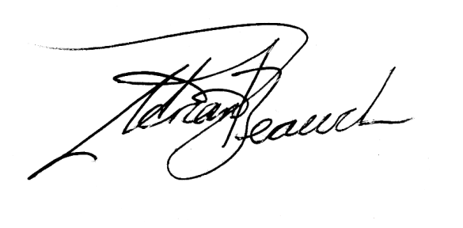Yours Respectfully,

____________________________________

Adrian Beauche

CEO, REALLY NICE MEDIA

Contact:  
Tel: 1 868 688 - 2777  
Email: adrian@reallynicemedia.com